CA Service Virtualization - Version 8.0

CA LISA has been renamed to DevTest Solutions.

- Methods of creating Virtual Services :
- Recording
- RR Pairs
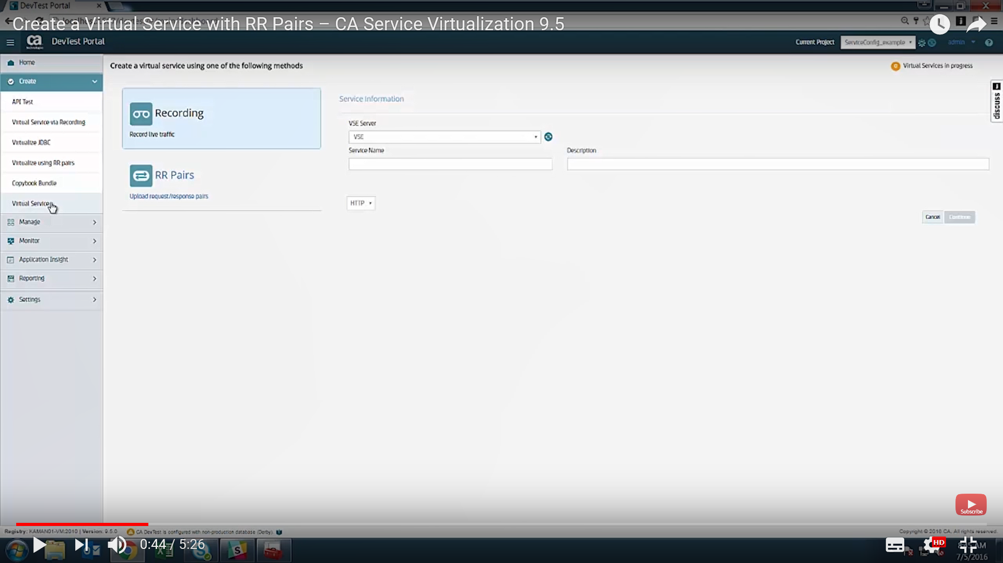

- Request Available Data Protocols:

- Web Services ( SOAP)
- XML Data protocol
- JSON
- Rest Data Protocols

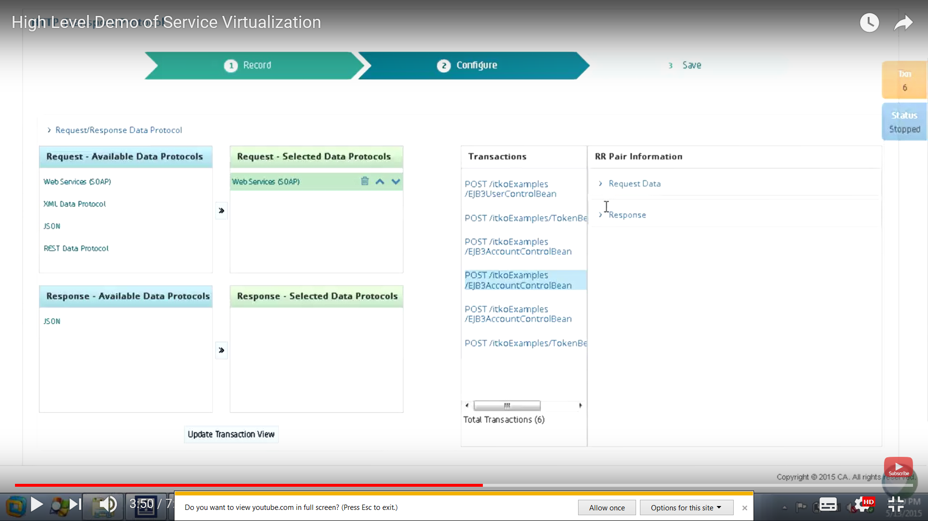

hahah

